Top of Form**A. Create a simple calculator application using servlet.**

**index.html**

<html>

<head>

<title>Calculator</title>

<meta charset="UTF-8">

<meta name="viewport" content="width=device-width, initial-scale=1.0">

<link rel="stylesheet" href="newcss.css">

</head>

<body>

<div class="container">

<form method="POST" action="MyServlet">

<h3 id="head">Calculator</h3><hr>

ENTER 1 NUMBER <input type="text" name="t1"><br><br>

ENTER 2 NUMBER <input type="text" name="t2"><br><br>

<select name="t3">

<option value="1">Addition</option>

<option value="2">Division</option>

<option value="3">Multiplication</option>

<option value="4">Subtraction</option>

</select><br><br>

<input id="btn" type="submit" value="submit"><br>

</form>

</div></body></html>

**MyServlet.java**

import java.io.IOException;

import java.io.PrintWriter;

import javax.servlet.ServletException;

import javax.servlet.annotation.WebServlet;

import javax.servlet.http.HttpServlet;

import javax.servlet.http.HttpServletRequest;

import javax.servlet.http.HttpServletResponse;

@WebServlet(urlPatterns = {"/MyServlet"})

public class MyServlet extends HttpServlet {

protected void processRequest(HttpServletRequest request, HttpServletResponse response)

throws ServletException, IOException {

response.setContentType("text/html;charset=UTF-8");

try (PrintWriter out = response.getWriter()) {

/* TODO output your page here. You may use following sample code. */

out.println("<!DOCTYPE html>");

out.println("<html>");

out.println("<head>");

out.println("<title>Servlet MyServlet</title>");

out.println("</head>");

out.println("<body>");

int a=Integer.parseInt(request.getParameter("t1"));

int b=Integer.parseInt(request.getParameter("t2"));

int opt=Integer.parseInt(request.getParameter("t3"));

switch(opt){

case 1:

out.println("<h1>Addition of two numbers are: " +(a+b)+"</h1>");

break;

case 2:

out.println("<h1>Division of two numbers are: " +(a/b)+"</h1>");

break;

case 3:

out.println("<h1>Multiplication of two numbers are: " +(a*b)+"</h1>");

break;

case 4:

out.println("<h1>Subtration of two numbers are: " +(a-b)+"</h1>");

}

out.println("</body>");

out.println("</html>");

}

}

@Override

protected void doGet(HttpServletRequest request, HttpServletResponse response)

throws ServletException, IOException {

processRequest(request, response);

}

@Override

protected void doPost(HttpServletRequest request, HttpServletResponse response)

throws ServletException, IOException {

processRequest(request, response);

}

@Override

public String getServletInfo() {

return "Short description";

}// </editor-fold>}

**Newcss.css**

body{

background-color: purple;

}

form{

background-color: white;

border-radius: 10px;}

#id{

font-size: 20px;

text-align: center;

}

.container{

width:450px;

max-width: 500px;

position: absolute;

top: 150px;

left: 400px;

margin: auto;

}

form{

padding-left: 60px;

padding-top: 10px;

margin: auto;

}

#btn{

height:30px;

width: 80px;

background-color: pink;

border-radius: 2px solid black;

margin-left: 120px;}

**Output:**

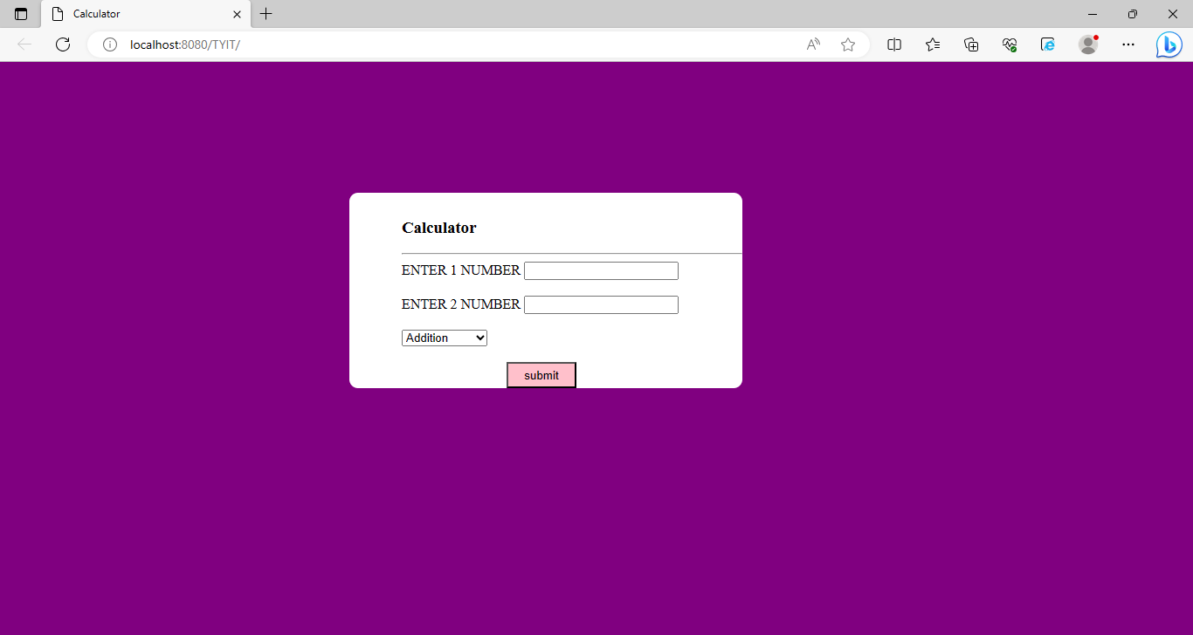

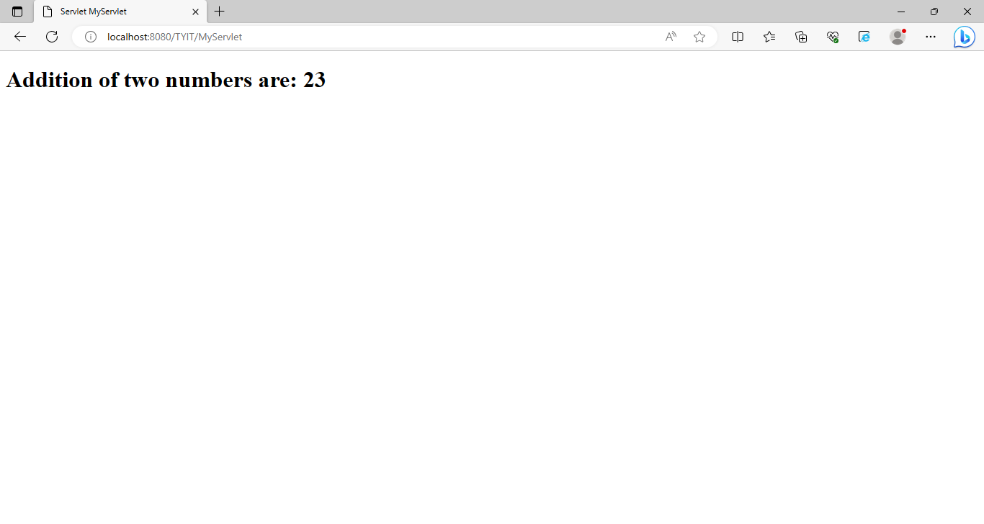

**B. Create a servlet for a login page. If the username and password are correct then it**

**says message “Hello <username>” else a message “login failed”**

**Login.html**

<!DOCTYPE html>

<!--

To change this license header, choose License Headers in Project Properties.

To change this template file, choose Tools | Templates

and open the template in the editor.

-->

<html>

<head>

<title>Login Form</title>

<meta charset="UTF-8">

<meta name="viewport" content="width=device-width, initial-scale=1.0">

<link rel="stylesheet" href="newcss.css"/>

</head>

<body>

<form class="form" action="NewServlet" method="post" >

<h3>Login Form</h3> <hr>

<div class="user">

Username: <input type="text" name="Username" placeholder="Username" ><br><br>

Password: <input type="password" name="password" placeholder="password" required><br></div>

<input type="submit" value="LogIn" id="btn">

</form> </body></html>

**Newcss.css**

body{

background-color: purple;

padding-left: 400px;

padding-right: 450px;

padding-top: 90px

}

form{

background-color: whitesmoke;

text-align: center;

padding-right:50px;

padding-bottom: 50px;

border-radius:10px;

}

#btn{

margin-top:60px;

height:30px;

width:70px;

border-radius: 10px;

border:2px solid black;}

#btn:hover{

background-color: pink}

hr{

margin-left: 40px}

.user{

padding-top: 10px}

**NewServlet.java**

import java.io.IOException;

import java.io.PrintWriter;

import javax.servlet.ServletException;

import javax.servlet.http.HttpServlet;

import javax.servlet.http.HttpServletRequest;

import javax.servlet.http.HttpServletResponse;

public class NewServlet extends HttpServlet {

protected void processRequest(HttpServletRequest request, HttpServletResponse response)

throws ServletException, IOException {

response.setContentType("text/html;charset=UTF-8");

try (PrintWriter out = response.getWriter()) {

/* TODO output your page here. You may use following sample code. */

out.println("<!DOCTYPE html>");

out.println("<html>");

out.println("<head>");

out.println("<title>Servlet NewServlet</title>");

out.println("</head>");

out.println("<body>");

String a=request.getParameter("password");

String b=request.getParameter("Username");

if(a.equalsIgnoreCase("admin"))

{

out.println("<h1>Hello "+b+"</h1>");

}

else

{

out.println("<h2>Login failed!!</h2>");

}

out.println("</body>");

out.println("</html>");

} }

@Override

protected void doGet(HttpServletRequest request, HttpServletResponse response)

throws ServletException, IOException {

processRequest(request, response); }

@Override

protected void doPost(HttpServletRequest request, HttpServletResponse response)

throws ServletException, IOException {

processRequest(request, response);

}

@Override

public String getServletInfo() {

return "Short description";

}// </editor-fold>

}

**Output:**

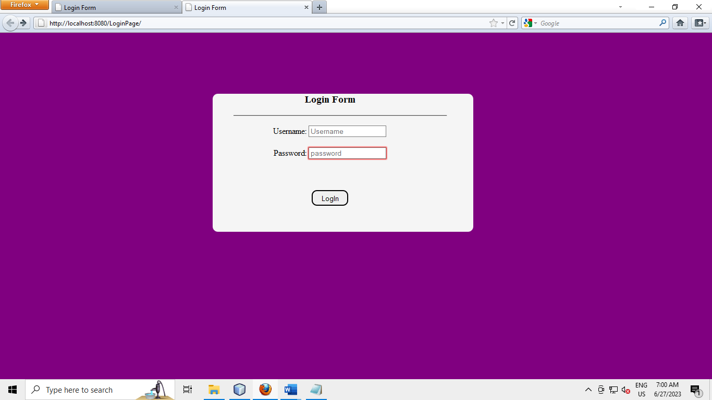

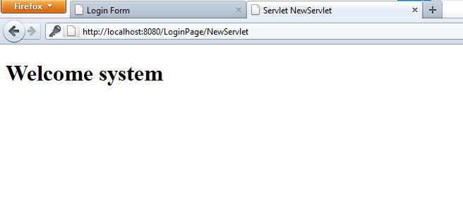

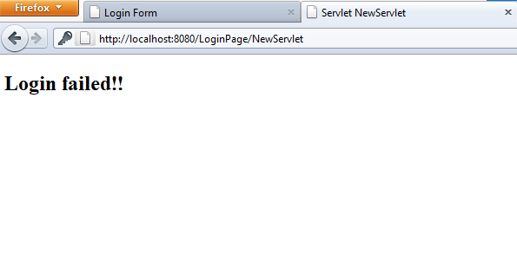

**C. Create a servlet that uses Cookies to store the number of times a user has visited**

**Servlet.**

**NewServlet.java**

import java.io.IOException;

import java.io.PrintWriter;

import javax.servlet.ServletException;

import javax.servlet.http.Cookie;

import javax.servlet.http.HttpServlet;

import javax.servlet.http.HttpServletRequest;

import javax.servlet.http.HttpServletResponse;

public class NewServlet4 extends HttpServlet {

static int i=1;

protected void processRequest(HttpServletRequest request, HttpServletResponse response)

throws ServletException, IOException {

response.setContentType("text/html;charset=UTF-8");

try (PrintWriter out = response.getWriter()) {

/* TODO output your page here. You may use following sample code. */

out.println("<!DOCTYPE html>");

out.println("<html>");

out.println("<head>");

out.println("<title>Servlet NewServlet4</title>");

out.println("</head>");

out.println("<body>");

Cookie c=new Cookie("Visit",String.valueOf(i));

response.addCookie(c);

int j=Integer.parseInt(c.getValue());

if(j==1){

out.println("Welcome User");

}

else{

out.println("You have visited this website "+j+"times");

}

i++;

out.println("</body>");

out.println("</html>");

}

}

@Override

protected void doGet(HttpServletRequest request, HttpServletResponse response)

throws ServletException, IOException {

processRequest(request, response);

}

@Override

protected void doPost(HttpServletRequest request, HttpServletResponse response)

throws ServletException, IOException {

processRequest(request, response);

}

@Override

public String getServletInfo() {

return "Short description";

}// </editor-fold>

}

**Output:**

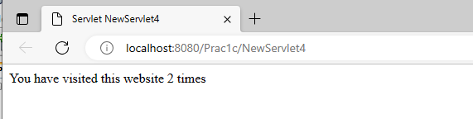

**D. Create a servlet demonstrating the use of session creation and destruction. Also check whether the user has visited this page first time or has visited earlier also using sessions.**

**Sessionprog.java**

import java.io.IOException;

import java.io.PrintWriter;

import javax.servlet.ServletException;

import javax.servlet.http.HttpServlet;

import javax.servlet.http.HttpServletRequest;

import javax.servlet.http.HttpServletResponse;

import javax.servlet.http.HttpSession;

import java.util.Date;

public class sessionprog extends HttpServlet {

static int count;

protected void processRequest(HttpServletRequest request, HttpServletResponse response)

throws ServletException, IOException {

response.setContentType("text/html;charset=UTF-8");

try (PrintWriter out = response.getWriter()) {

/* TODO output your page here. You may use following sample code. */

out.println("<!DOCTYPE html>");

out.println("<html>");

out.println("<head>");

out.println("<title>Servlet sessionprog</title>");

out.println("</head>");

out.println("<body>");

HttpSession session=request.getSession(true);

if(session.isNew())

{

out.println("Welcome, Newcomer");

count=0;

}

else{

out.println("Welcom Back");

count++;

}

out.println("<TABLE BORDER=1 ALIGN=CENTER>\n");

out.println("<TR BGCOLOR=\"#FFADQQ\">\n");

out.println("<TH>Info Type<TH>Value\n");

out.println("<TR>\n");

out.println("<TD>ID<TD>"+ session.getId()+"\n");

out.println("<TR>\n");

out.println("<TD>Creation Time<TD>"+ new Date(session.getCreationTime())+"\n");

out.println("<TR>\n");

out.println("<TD>Time of Last Acess<TD>"+ new Date(session.getLastAccessedTime())+"\n");

out.println("<TR>\n");

out.println("<TD>Number of previous Access<TD>"+count+"\n");

out.println("</table>");

if(count>=10)

{

session.invalidate();

}

out.println("</body>");

out.println("</html>");

}

}

@Override

protected void doGet(HttpServletRequest request, HttpServletResponse response)

throws ServletException, IOException {

processRequest(request, response);

}

@Override

protected void doPost(HttpServletRequest request, HttpServletResponse response)

throws ServletException, IOException {

processRequest(request, response);}

@Override

public String getServletInfo() {

return "Short description";

}// </editor-fold>

}

**Output:**

